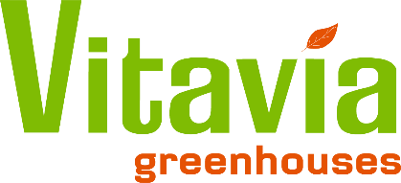

Vitavia Returns Policy
If for any reason you are not satisfied with the product you have received, simply place it back unused and in its original packaging and return it to us within 14 days of its delivery.
We will refund you 100% of the purchase price minus delivery and collection charges that we will agree prior to return/pick-up.
How To Return a Product
If you would like to return something please email info@vitavia.co.uk and we can agree the procedure with you.
Return a Faulty Product
If you think a product you have bought from us may be faulty please email info@vitavia.co.uk and we will be able to send out replacement parts.
Product Returns
Any carriage charges for the return of a greenhouse will be paid for by the customer returning the greenhouse
Your statutory rights are not affected by this guarantee.

